**Diploma in Native Application Assignment**

**MODULE: 1**

**SE – Overview of IT Industry**

**Name: Patel Avi N.**

1. **What is Software? What is software engineering?**

Software is a program or set of programs containing instructions to provide desire functionality.

Engineering is a process of designing and building something that find a cost-effective solution to problems.

Software engineering is the process of designing, developing, testing, and maintaining software.

1. **Explain types of software.**

**System Software:** Provides essential functionalities for operating computer hardware and managing resources, such as operating systems, device drivers, and utility programs.

**Application Software:** Designed to perform specific tasks or applications for users, such as word processors, spreadsheets, web browsers, and multimedia software.

**Embedded Software:** Embedded within devices or systems to control their functionality, such as firmware in microcontrollers, automotive software, or industrial control systems.

**Mobile Apps:** Software applications specifically developed for mobile devices, such as smartphones or tablets, to provide various functionalities and services.

1. **What is SDLC? Explain each phase of SDLC.**

**SDLC (Software Development Life Cycle):**

SDLC is a process framework used in software engineering to guide the development of software systems. It consists of several phases:

**Requirements Gathering:** Collecting and analysing user requirements for the software.

**System Design:** Creating the overall system architecture and design based on the requirements.

**Implementation:** Developing the actual software code based on the design specifications.

**Testing:** Verifying and validating the software to ensure it meets the desired quality standards and functions correctly.

**Deployment:** Installing the software in the intended environment and making it operational for users.

**Maintenance:** Making modifications, fixing bugs, and providing ongoing support for the software throughout its lifecycle.

1. **What is DFD? Create a DFD diagram on Flipkart.**

**DFD (Data Flow Diagram):**

DFD is a graphical representation that illustrates the flow of data within a system or process. It shows how data is input, processed, and output within the system.

1. **What is Flow chart? Create a flowchart to make addition of two numbers.**

A flowchart is a visual representation of a process or algorithm, using different symbols to represent various steps or actions.

Here is a simple flowchart for adding two numbers:

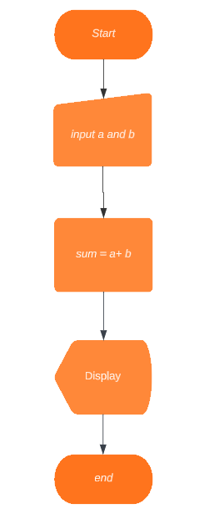

1. **What is Use case Diagram? Create a use-case on bill payment on paytm.**

A use case diagram is a visual representation that shows the interactions between actors (users or external systems) and a system to achieve specific goals. Here's an example of a use case diagram for bill payment on Paytm:

- Enter bill details

- Select payment method

- Authenticate payment

- Process payment